|  |  |
| --- | --- |
| EOL  End Of Life | |
| **Summary** | This is the Software Detailed Design Document for the *DAIMLER MMA* Project. |

|  |  |  |
| --- | --- | --- |
| **Author** | **Review** | **Approval** |
| Title: Stefan Dominte | See Project Master Document for the roles and Project Members List for the name of people | See Project Master Document for the roles and Project Members List for the name of people |
|  |  |  |
| **Distribution** | | |
| See Project Master Document for the roles and Project Members List for the name of people | See Project Master Document for the roles and Project Members List for the name of people | See Project Master Document for the roles and Project Members List for the name of people |

Table of contents

General Information 4

1.1. Revision history * 4

1.2. Purpose and Scope 4

1.3. Referenced documents 4

1.3.1. External documents 4

1.3.2. Internal Documents 4

1.3.3. Terminology and definitions 5

2. SW Module Detailed Design 6

2.1. Overview 6

2.2. Traceability 6

3. Features 8

3.1. Services 8

3.1.1. EOL_runMainFunction 8

3.1.2. eol_ GetCounterIndex 9

3.1.3. eol_ManageCycleCounters 10

3.1.4. eol_CalculateObsolescenseData 11

3.1.5. EOL_Get_Obsolescence_Data 12

3.1.6. EOL_Write_Obsolescence_Data 13

3.1.7. eol_GetVariableCounterValue 14

3.2. Runnabes – Auto-tests 15

3.2.1. EOL_Autotest_CheckProductEndOfLifeComfort 15

3.2.2. EOL_Autotest_CheckProductEndOfLifeLowForce 16

3.2.3. EOL_Autotest_CheckProductEndOfLifeHighForce 17

3.2.4. EOL_Autotest_CheckProductEndOfLifeMaxForce 18

3.3. Variabiles 19

3.3.1. EOL_u8OldExecutedCycleNumber 19

3.3.2. eol_stObsolescenseData 19

3.4. Macros 20

3.4.1. KU8_EOL_COMFORT_LEVEL 20

3.4.2. KU8_EOL_LOW_FORCE_LEVEL 20

3.4.3. KU8_EOL_HIGH_FORCE_LEVEL 20

3.4.4. KU8_EOL_MAX_FORCE_LEVEL 20

3.4.5. KU8_EOL_REQUEST_COUNTER_LEVEL 20

3.4.6. COUNTER_LIMIT_ENABLED 21

3.4.7. KU8_NB_MONITORED_CYCLES 21

3.4.8. KU8_VARIABLE_COUNTER_LOW 21

3.4.9. KU8_VARIABLE_COUNTER_HIGH 21

3.4.10. KU8_VARIABLE_COUNTER_MAX 21

3.4.11. KU8_VARIABLE_COUNTER_COMFORT 22

4. EEPROM 22

5. Configuration 22

6. Compilation Options 22

# Tables of figures

Figure 1: EOL_runMainFunction 9

Figure 2: eol_GetCounterIndex Part1 10

Figure 3: eol_GetCounterIndex Part2 10

Figure 4: eol_ManageCycleCounters 11

Figure 5: eol_CalculateObsolescenseData: 12

Figure 6: EOL_Get_Obsolescence_Data 13

Figure 7: EOL_Write_Obsolescence_Data 14

Figure 8: eol_GetVariableCounterValue Part1 15

Figure 9: eol_GetVariableCounterValue Part2 15

Figure 10: EOL_Autotest_CheckProductEndOfLifeComfort 16

Figure 11: EOL_Autotest_CheckProductEndOfLifeLowForce 17

Figure 12: EOL_Autotest_CheckProductEndOfLifeHighForce 18

Figure 13: EOL_Autotest_CheckProductEndOfLifeMaxForce 19

# General Information

## Revision history *

|  |  |  |  |
| --- | --- | --- | --- |
| **Revision** | **Date** | **Author(s)** | **Description/comment** |
| 1.1.2.2 | 08/06/2022 | Stefan Dominte | Initial revision |
| 1.1.2.3 | 16/06/2022 | Stefan Dominte | Traceability updated |
| 1.1.2.4 | 16/06/2022 | Stefan Dominte | Traceability reupdated |
| 1.1.2.5 | 29/08/2022 | Stefan Dominte | Updated for 3.0 release |
| 1.1.2.6 | 15/11/2022 | Stefan Dominte | Updated for 4.0 release |
| 1.1.2.7 | 06/02/2023 | Stefan Dominte | Updated for 5.0 release |
| 1.1.2.8 | 05/05/2023 | Stefan Dominte | Updated for 6.0 release |
| 1.1.2.9 | 21/06/2023 | Madalina Serban | Updated for 6.1 release |
| 1.1.2.10 | 22/06/2023 | Madalina Serban | Updated traceability |
| 1.1.2.11 | 22/06/2023 | Madalina Serban | Updated internal document version |
| 1.1.2.12 | 22/06/2023 | Madalina Serban | Updated internal document version |
|  |  |  |  |
|  |  |  |  |
|  |  |  |  |
|  |  |  |  |
|  |  |  |  |
|  |  |  |  |
|  |  |  |  |
|  |  |  |  |

*\* Template history is found in the CM tool used for templates*

## Purpose and Scope

The purpose of this document is to provide an overview of the EOL operation principle, and to present the implementation choices in terms of module and function splitting.

## Referenced documents

### External documents

|  |  |  |
| --- | --- | --- |
| **Id** | **Title** | **Reference** |
|  |  |  |
|  |  |  |
|  |  |  |

### Internal Documents

|  |  |  |
| --- | --- | --- |
| **Id** | **Title** | **Reference** |
|  | DAIMLER_MMA_SWarchitectureDesignInterfaceDescription.docx |  |
|  | EOL - Design Interface Description.docx |  |
|  | SBE_4G_NVP_layout.xls |  |
|  |  |  |

### Terminology and definitions

|  |  |
| --- | --- |
| **Terminology** | **Meaning** |
| AAU | Atomic architectural unit |
| SW | Software |
|  |  |

# SW Module Detailed Design

## Overview

EOL (End Of Life) is a very small SW unit intended to count the number of times belt functions are triggered and to notify that the end of life of a belt function (or a group of belt functions) is reached.

From a static point of view, EOL is connected to 3 SW units:

* BFE: To read / detect any cycles start (based on executed cycle data)
* NVP: To load EOL thresholds, to record EOL counters
* CIL: To read / detect any PreSafe request and the specific level requested

## Traceability

|  |  |  |  |
| --- | --- | --- | --- |
| Requirements | Criteria | Linked Runnable | Source |
| DSG_EOL_0001 | This component shall update the low force counter when HWA profiles (cycles 18, 20, 22 and 24) or tensioning cycles 0, 1 are executed. | EOL_RunMainFunction() | ARCH_SW_EOL_0002 |
| DSG_EOL_0002 | This component shall update the high force counter when tensioning cycles 2 and 3 are executed. | EOL_RunMainFunction() | ARCH_SW_EOL_0001 |
| DSG_EOL_0003 | This component shall update the comfort counter when BSR profiles (cycles 26,27 and 28) or tensioning cycles 14, 15, 16 and 17 are executed. | EOL_RunMainFunction() | ARCH_SW_EOL_0003 |
| DSG_EOL_0004 | The local variable EOL_u8OldExecutedCycleNumber will hold the the old value of the executed cycle number | EOL_RunMainFunction() | ARCH_SW_EOL_0007 |
| DSG_EOL_0005 | The component shall update the Low force counter when the High force counter is incremented. | EOL_RunMainFunction() | ARCH_SW_EOL_0008 |
| DSG_EOL_0006 | This component shall check if the end of life of the “low force” belt functions is reached. | EOL_Autotest_CheckProductEndOfLifeLowForce() | ARCH_SW_EOL_0004 |
| DSG_EOL_0007 | This component shall check if the end of life of the “high force” belt functions is reached. | EOL_Autotest_CheckProductEndOfLifeHighForce() | ARCH_SW_EOL_0005 |
| DSG_EOL_0008 | This component shall check if the end of life of the “comfort” belt functions is reached. | EOL_Autotest_CheckProductEndOfLifeComfort() | ARCH_SW_EOL_0006 |
| DSG_EOL_0009 | This component shall read the executed cycle number in order to increment specific counter. | EOL_RunMainFunction() | ARCH_SW_EOL_0009 |
| DSG_EOL_0010 | This component shall check if the end of life of the “max force” belt functions is reached. | EOL_Autotest_CheckProductEndOfLifeMaxForce() | ARCH_SW_EOL_0012 |
| DSG_EOL_0011 | This component shall update the max force counter tensioning cycles 4, 5 and 6 are executed. | EOL_RunMainFunction() | ARCH_SW_EOL_0010 |
| DSG_EOL_0012 | This component shall update the request counter when tensioning cycles 0-6 or HWA profile are executed. | EOL_RunMainFunction() | ARCH_SW_EOL_0011 |
| DSG_EOL_0013 | The local function eol_ManageCycleCounters will read the trigger request value in order to check if a PRE-SAFE request is active. | EOL_RunMainFunction() | ARCH_SW_EOL_0013 |
| DSG_EOL_0014 | The local function eol_ManageCycleCounters will read the pre safe level value in order to check which presafe level is active. | EOL_RunMainFunction() | ARCH_SW_EOL_0014 |
| DSG_EOL_0015 | The local function eol_ManageCycleCounters will update the NVM block status. | EOL_RunMainFunction() | ARCH_SW_EOL_0015; ARCH_SW_EOL_0023 |
| DSG_EOL_0016 | The local function eol_ManageCycleCounters will update the Obsolescense Data block number. | EOL_RunMainFunction() | ARCH_SW_EOL_0016 |
| DSG_EOL_0017 | This component shall update the associated cycle counter (low, high, max, comfort) when tensioning cycles 7, 8, 9, 10, 11, 12 and 13 are executed. | EOL_RunMainFunction() | ARCH_SW_EOL_0017 |
| DSG_EOL_0018 | The local function eol_GetCounterIndex will set the corresponding counter to low when the associated cycle counter configuration value is 1. | EOL_RunMainFunction() | ARCH_SW_EOL_0018 |
| DSG_EOL_0019 | The local function eol_GetCounterIndexwill set the corresponding counter to high when the associated cycle counter configuration value is 2. | EOL_RunMainFunction() | ARCH_SW_EOL_0019 |
| DSG_EOL_0020 | The local function eol_GetCounterIndex will set the corresponding counter to max when the associated cycle counter configuration value is 4. | EOL_RunMainFunction() | ARCH_SW_EOL_0020 |
| DSG_EOL_0021 | The local function eol_GetCounterIndex will set the corresponding counter to comfort when the associated cycle counter configuration value is 8. | EOL_RunMainFunction() | ARCH_SW_EOL_0021 |
| DSG_EOL_0022 | The local function eol_GetCounterIndex will set the corresponding counter to low when the associated cycle counter configuration value is different than 1,2,4 and 8. | EOL_RunMainFunction() | ARCH_SW_EOL_0022 |

# Features

## Services

### EOL_runMainFunction

|  |  |  |
| --- | --- | --- |
| Object | | |
| Call the main function of the EOL module | | |
| **Prototype** | | |
| void EOL_runMainFunction(void) | | |
| **Input parameters** | | |
| Name | Type | Description |
| NA | NA | NA |
| **Output parameters** | | |
| Name | Type | Description |
| NA | NA | NA |
| **Return value** | | |
| Type | Description | |
| NA | void | |
| **Dynamic aspect** | | |
| Who(callers) | Description | |
| OS | Every 10 ms | |
| **Static aspect** | | |
| NA | | |
| **Constrains** | | |
| NA | | |

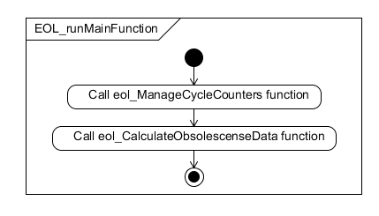

Figure : EOL_runMainFunction

### eol_ GetCounterIndex

|  |  |  |
| --- | --- | --- |
| Object | | |
| Defines the cycle counter | | |
| **Prototype** | | |
| LOCAL uint8 eol_GetCounterIndex(const uint8 u8ExecutedCycleNumber) | | |
| **Input parameters** | | |
| Name | Type | Description |
| u8ExecutedCycleNumber | Uint8 | executed cycle number |
| **Output parameters** | | |
| Name | Type | Description |
| NA | NA | NA |
| **Return value** | | |
| Type | Description | |
| NA | void | |
| **Dynamic aspect** | | |
| Who(callers) | Description | |
| EOL_runMainFunction | Every main function call. | |
| **Static aspect** | | |
| NA | | |
| **Constrains** | | |
| NA | | |

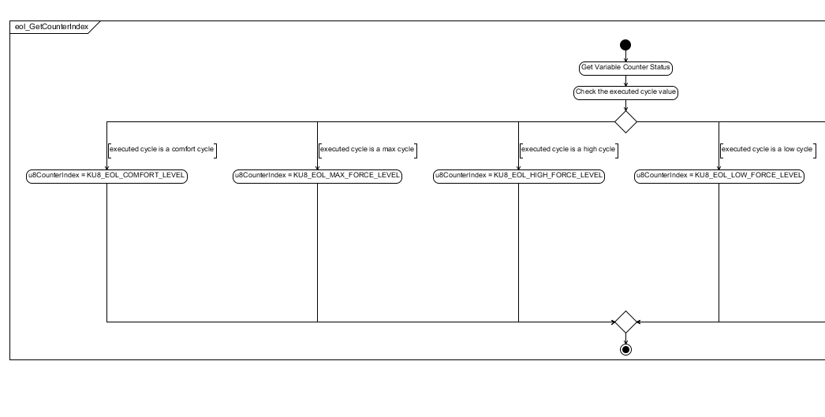

Figure : eol_GetCounterIndex Part1

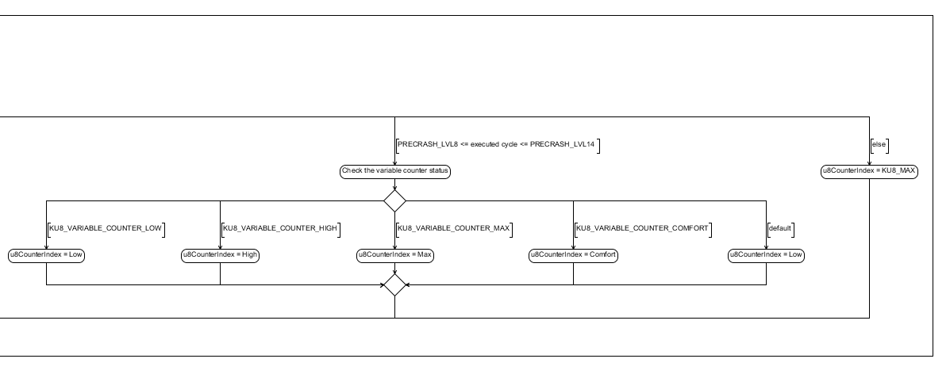

Figure : eol_GetCounterIndex Part2

### eol_ManageCycleCounters

|  |  |  |
| --- | --- | --- |
| Object | | |
| Computes cycles counters | | |
| **Prototype** | | |
| LOCAL uint8 eol_GetCounterIndex(const uint8 u8ExecutedCycleNumber) | | |
| **Input parameters** | | |
| Name | Type | Description |
| NA | NA | NA |
| **Output parameters** | | |
| Name | Type | Description |
| NA | NA | NA |
| **Return value** | | |
| Type | Description | |
| NA | void | |
| **Dynamic aspect** | | |
| Who(callers) | Description | |
| EOL_runMainFunction | Every main function call. | |
| **Static aspect** | | |
| NA | | |
| **Constrains** | | |
| NA | | |

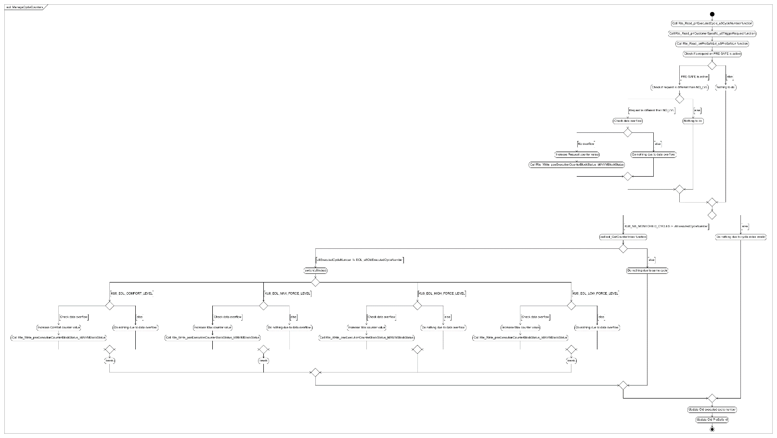

Figure : eol_ManageCycleCounters

### eol_CalculateObsolescenseData

|  |  |  |
| --- | --- | --- |
| Object | | |
| Computes obsolescense data values | | |
| **Prototype** | | |
| LOCAL void eol_CalculateObsolescenseData(void) | | |
| **Input parameters** | | |
| Name | Type | Description |
| NA | NA | NA |
| **Output parameters** | | |
| Name | Type | Description |
| NA | NA | NA |
| **Return value** | | |
| Type | Description | |
| NA | void | |
| **Dynamic aspect** | | |
| Who(callers) | Description | |
| EOL_runMainFunction | Every main function call. | |
| **Static aspect** | | |
| NA | | |
| **Constrains** | | |
| NA | | |

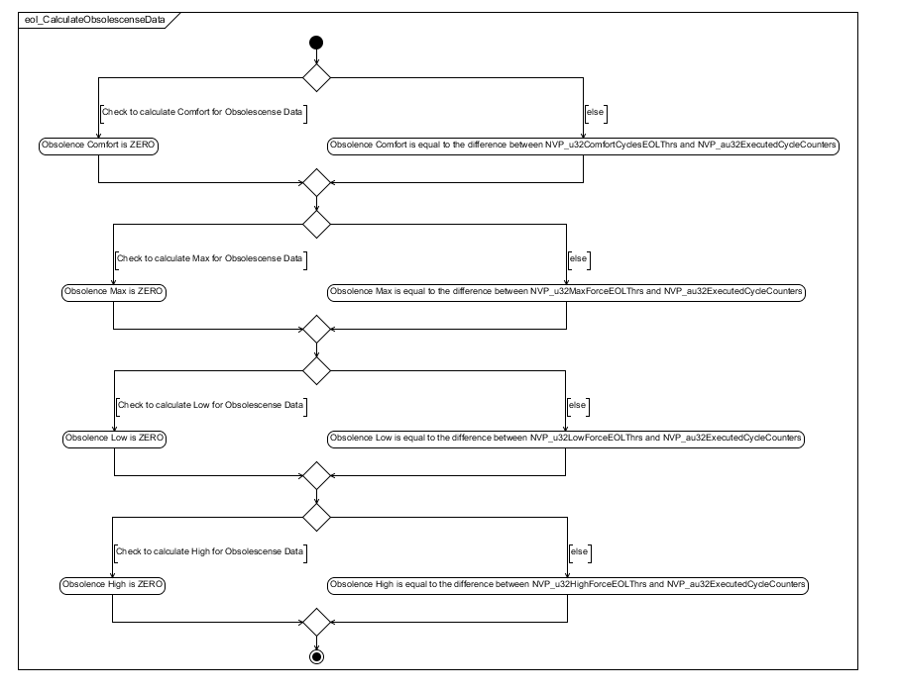

Figure : eol_CalculateObsolescenseData:

### EOL_Get_Obsolescence_Data

|  |  |  |
| --- | --- | --- |
| Object | | |
| Functions to get obsolence data | | |
| **Prototype** | | |
| FUNC(void, EOL_AC_EndOfLifeManagement_CODE) EOL_Get_Obsolescence_Data(P2CONST(Impl_Obsolescense_Data, AUTOMATIC, RTE_EOL_AC_ENDOFLIFEMANAGEMENT_APPL_DATA) pObsData) | | |
| **Input parameters** | | |
| Name | Type | Description |
| NA | NA | NA |
| **Output parameters** | | |
| Name | Type | Description |
| pObsData | Impl_Obsolescense_Data | Obsolescense data |
| **Return value** | | |
| Type | Description | |
| NA | void | |
| **Dynamic aspect** | | |
| Who(callers) | Description | |
|  |  | |
| **Static aspect** | | |
| NA | | |
| **Constrains** | | |
| NA | | |

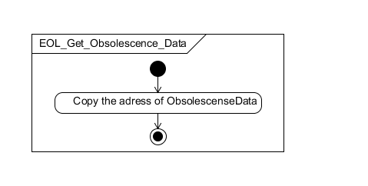

Figure : EOL_Get_Obsolescence_Data

### EOL_Write_Obsolescence_Data

|  |  |  |
| --- | --- | --- |
| Object | | |
| Functions to write obsolence data | | |
| **Prototype** | | |
| FUNC(void, EOL_AC_EndOfLifeManagement_CODE) EOL_Write_Obsolescence_Data(P2VAR(Impl_Obsolescense_Data, AUTOMATIC, RTE_EOL_AC_ENDOFLIFEMANAGEMENT_APPL_VAR) pObsData) | | |
| **Input parameters** | | |
| Name | Type | Description |
| NA | NA | NA |
| **Output parameters** | | |
| Name | Type | Description |
| pObsData | Impl_Obsolescense_Data | Obsolescense data |
| **Return value** | | |
| Type | Description | |
| NA | void | |
| **Dynamic aspect** | | |
| Who(callers) | Description | |
|  |  | |
| **Static aspect** | | |
| NA | | |
| **Constrains** | | |
| NA | | |

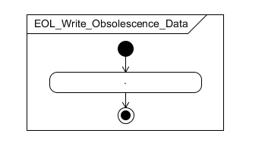

Figure : EOL_Write_Obsolescence_Data

### eol_GetVariableCounterValue

|  |  |  |
| --- | --- | --- |
| Object | | |
| Checks if a cycle has variable counter | | |
| **Prototype** | | |
| LOCAL uint8 eol_GetVariableCounterValue(const uint8 u8ExecutedCycleNumber) | | |
| **Input parameters** | | |
| Name | Type | Description |
| NA | NA | NA |
| **Output parameters** | | |
| Name | Type | Description |
| u8ExecutedCycleNumber | uint8 | executed cycle number |
| **Return value** | | |
| Type | Description | |
| Uint8 | value of the variable counter or 0xFF if no counter is configured | |
| **Dynamic aspect** | | |
| Who(callers) | Description | |
| eol_GetCounterIndex |  | |
| **Static aspect** | | |
| NA | | |
| **Constrains** | | |
| NA | | |

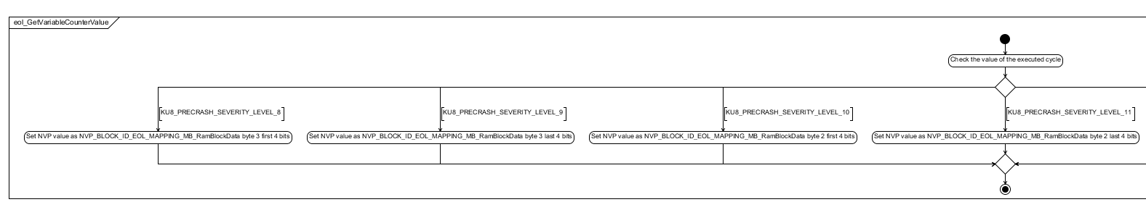

Figure : eol_GetVariableCounterValue Part1

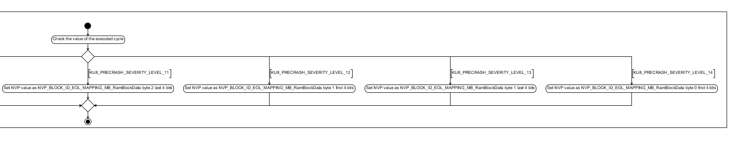

Figure : eol_GetVariableCounterValue Part2

## Runnabes – Auto-tests

### EOL_Autotest_CheckProductEndOfLifeComfort

|  |  |  |
| --- | --- | --- |
| Object | | |
| Check if comfort counter "end of life" is reached or not | | |
| **Prototype** | | |
| void EOL_Autotest_CheckProductEndOfLifeComfort(u8TestResultType * pu8TestResult) | | |
| **Input parameters** | | |
| Name | Type | Description |
| NA | NA | NA |
| **Output parameters** | | |
| Name | Type | Description |
| pu8TestResult | u8TestResultType | test result of the autotest |
| **Return value** | | |
| Type | Description | |
| NA | void | |
| **Dynamic aspect** | | |
| Who(callers) | Description | |
| NA | NA | |
| **Static aspect** | | |
| NA | | |
| **Constrains** | | |
| NA | | |

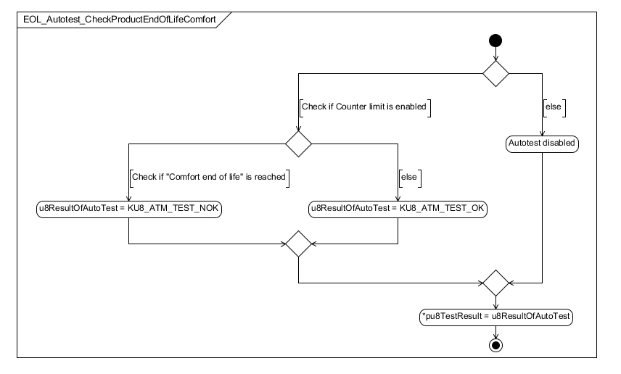

Figure : EOL_Autotest_CheckProductEndOfLifeComfort

### EOL_Autotest_CheckProductEndOfLifeLowForce

|  |  |  |
| --- | --- | --- |
| Object | | |
| Check if low force counter "end of life" is reached or not | | |
| **Prototype** | | |
| void EOL_Autotest_CheckProductEndOfLifeLowForce (u8TestResultType * pu8TestResult) | | |
| **Input parameters** | | |
| Name | Type | Description |
| NA | NA | NA |
| **Output parameters** | | |
| Name | Type | Description |
| pu8TestResult | u8TestResultType | test result of the autotest |
| **Return value** | | |
| Type | Description | |
| NA | void | |
| **Dynamic aspect** | | |
| Who(callers) | Description | |
| NA | NA | |
| **Static aspect** | | |
| NA | | |
| **Constrains** | | |
| NA | | |

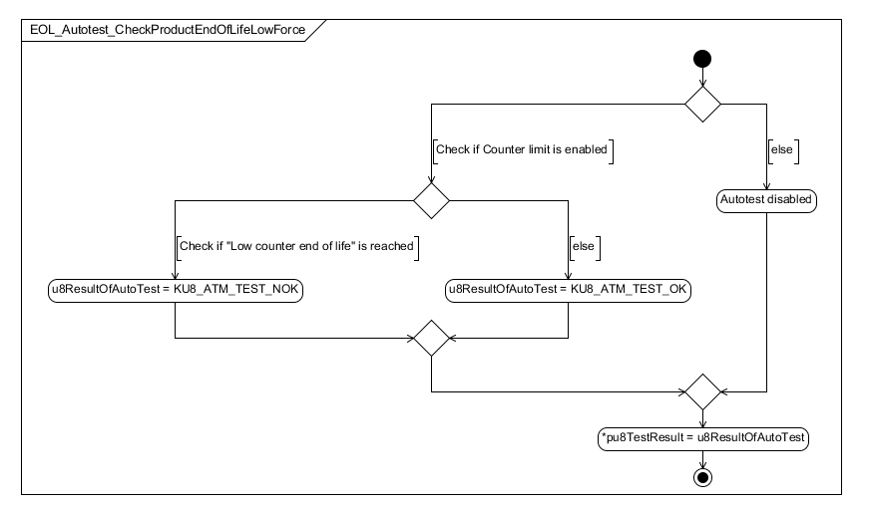

Figure : EOL_Autotest_CheckProductEndOfLifeLowForce

### EOL_Autotest_CheckProductEndOfLifeHighForce

|  |  |  |
| --- | --- | --- |
| Object | | |
| Check if high force counter "end of life" is reached or not | | |
| **Prototype** | | |
| void EOL_Autotest_CheckProductEndOfLifeHighForce (u8TestResultType * pu8TestResult) | | |
| **Input parameters** | | |
| Name | Type | Description |
| NA | NA | NA |
| **Output parameters** | | |
| Name | Type | Description |
| pu8TestResult | u8TestResultType | test result of the autotest |
| **Return value** | | |
| Type | Description | |
| NA | void | |
| **Dynamic aspect** | | |
| Who(callers) | Description | |
| NA | NA | |
| **Static aspect** | | |
| NA | | |
| **Constrains** | | |
| NA | | |

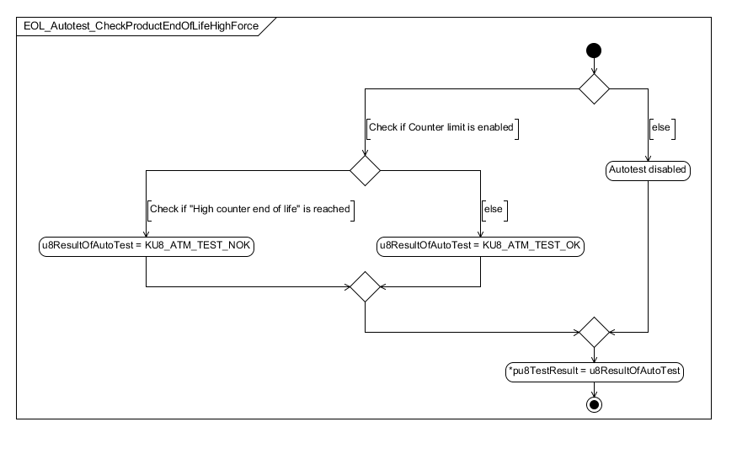

Figure : EOL_Autotest_CheckProductEndOfLifeHighForce

### EOL_Autotest_CheckProductEndOfLifeMaxForce

|  |  |  |
| --- | --- | --- |
| Object | | |
| Check if max force counter "end of life" is reached or not | | |
| **Prototype** | | |
| void EOL_Autotest_CheckProductEndOfLifeMaxForce (u8TestResultType * pu8TestResult) | | |
| **Input parameters** | | |
| Name | Type | Description |
| NA | NA | NA |
| **Output parameters** | | |
| Name | Type | Description |
| pu8TestResult | u8TestResultType | test result of the autotest |
| **Return value** | | |
| Type | Description | |
| NA | void | |
| **Dynamic aspect** | | |
| Who(callers) | Description | |
| NA | NA | |
| **Static aspect** | | |
| NA | | |
| **Constrains** | | |
| NA | | |

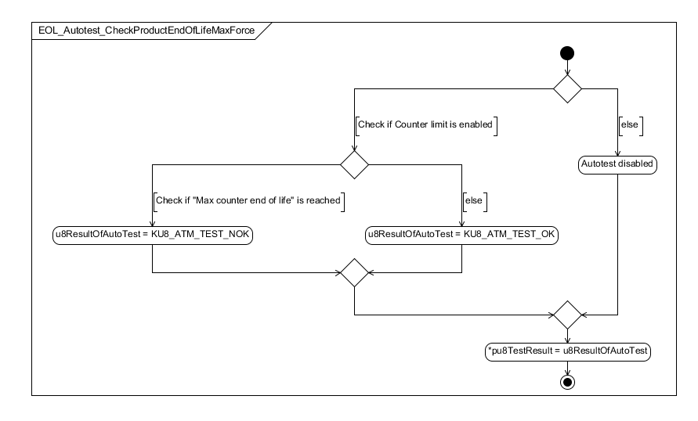

Figure : EOL_Autotest_CheckProductEndOfLifeMaxForce

## Variabiles

### EOL_u8OldExecutedCycleNumber

|  |  |  |
| --- | --- | --- |
| Type | Value |  |
| u8CycleNumberType | 0xFF | |
| **Description** | | |
| Store the old value of the executed cycle number | | |
| **Definition** | | |
| LOCAL u8CycleNumberType EOL_u8OldExecutedCycleNumber | | |

### eol_stObsolescenseData

|  |  |  |
| --- | --- | --- |
| Type | Value |  |
| Impl_Obsolescense_Data | 0x00 | |
| **Description** | | |
| Store the obsolenscense data | | |
| **Definition** | | |
| LOCAL Impl_Obsolescense_Data eol_stObsolescenseData = {0}; | | |

## Macros

### KU8_EOL_COMFORT_LEVEL

|  |  |
| --- | --- |
| Name | Value |
| Comfort cycle counter ID | 0x00 |
| **Definition** | |
| #define KU8_EOL_COMFORT_LEVEL | |
| **Description** | |
| NA | |

### KU8_EOL_LOW_FORCE_LEVEL

|  |  |
| --- | --- |
| Name | Value |
| Low force cycle counter ID | 0x01 |
| **Definition** | |
| #define KU8_EOL_LOW_FORCE_LEVEL | |
| **Description** | |
| NA | |

### KU8_EOL_HIGH_FORCE_LEVEL

|  |  |
| --- | --- |
| Name | Value |
| High force cycle counter ID | 0x02 |
| **Definition** | |
| #define KU8_EOL_HIGH_FORCE_LEVEL | |
| **Description** | |
| NA | |

### KU8_EOL_MAX_FORCE_LEVEL

|  |  |
| --- | --- |
| Name | Value |
| Max force cycle counter ID | 0x03 |
| **Definition** | |
| #define KU8_EOL_MAX_FORCE_LEVEL | |
| **Description** | |
| NA | |

### KU8_EOL_REQUEST_COUNTER_LEVEL

|  |  |
| --- | --- |
| Name | Value |
| Request force cycle counter ID | 0x04 |
| **Definition** | |
| #define KU8_EOL_REQUEST_COUNTER_LEVEL | |
| **Description** | |
| NA | |

### COUNTER_LIMIT_ENABLED

|  |  |
| --- | --- |
| Name | Value |
| Counter limit enable define | 0x00 |
| **Definition** | |
| #define COUNTER_LIMIT_ENABLED | |
| **Description** | |
| NA | |

### KU8_NB_MONITORED_CYCLES

|  |  |
| --- | --- |
| Name | Value |
| Define used to limit the number of cycles monitored by the EOL module | 31 |
| **Definition** | |
| #define KU8_NB_MONITORED_CYCLES | |
| **Description** | |
| NA | |

### KU8_VARIABLE_COUNTER_LOW

|  |  |
| --- | --- |
| Name | Value |
| Variable counter low id | 1 |
| **Definition** | |
| #define KU8_VARIABLE_COUNTER_LOW | |
| **Description** | |
| NA | |

### KU8_VARIABLE_COUNTER_HIGH

|  |  |
| --- | --- |
| Name | Value |
| Variable counter high id | 2 |
| **Definition** | |
| #define KU8_VARIABLE_COUNTER_HIGH | |
| **Description** | |
| NA | |

### KU8_VARIABLE_COUNTER_MAX

|  |  |
| --- | --- |
| Name | Value |
| Variable counter max id | 4 |
| **Definition** | |
| #define KU8_VARIABLE_COUNTER_MAX | |
| **Description** | |
| NA | |

### KU8_VARIABLE_COUNTER_COMFORT

|  |  |
| --- | --- |
| Name | Value |
| Variable counter comfort id | 8 |
| **Definition** | |
| #define KU8_VARIABLE_COUNTER_COMFORT | |
| **Description** | |
| NA | |

# EEPROM

The EEPROM parameters are all specified in [Doc3 = SBE_4G_NVP_layout.xls].

Refer to this document for more details.

# Configuration

No special configuration for EOL software component.

# Compilation Options

No compilation options for EOL software component.